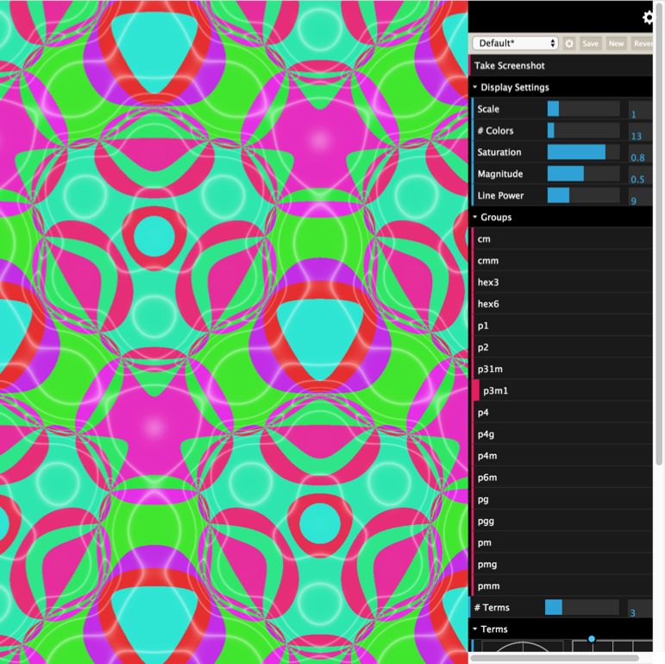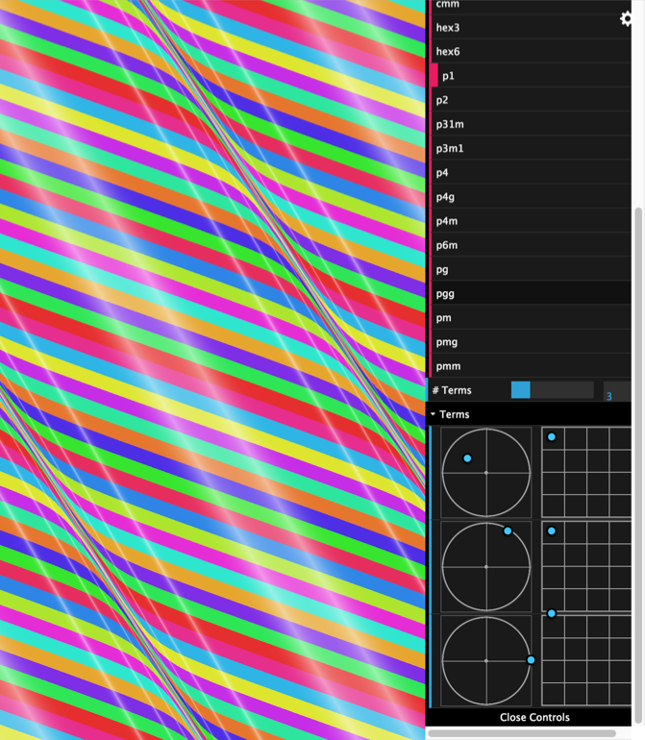

## Summary

We created a web application to create and display wallpaper patterns based on the 17 plane symmetry groups (<https://en.wikipedia.org/wiki/Wallpaper_group)>. We wrote a web app that runs in the browser and has the following features implemented:

* Dynamic loading of 17 distinct fragment shaders written in GLSL ES 2.0, one for each wallpaper group.
* All of the code was written in TypeScript (<https://www.typescriptlang.org/)> and transcompiled to JavaScript. This allowed us to enforce type safety while also learn a new language.
* We’ve built on dat.gui (<https://github.com/dataarts/dat.gui)> user interface library and built on it to create custom controls to select a wallpaper group, modify various parameters like the wave direction and magnitude, take image screenshots, and save app settings.
* We’ve used ThreeJS (<https://threejs.org/)> WebGL library to simplify the boilerplate code required to interface with the 3D canvas.

We wanted to implement the functionality of uploading an image file that the wallpaper colors would be selected from as we had originally planned, but ran out of time. Working with git (a source control tool) was also challenging at times. Kelly couldn't sleep for two nights straight after a failed git merge. At a certain point she hasn't seen her dog for 3 days because she was so busy at school trying to fix the bugs.

## Individual Contributions

|  |  |
| --- | --- |
| Yevgeni:   * Research into project idea and tooling. * All HTML code * Majority of user interface and core app development | Kelly   * Created shaders to display each of the 17 wallpaper patterns (one shader per pattern) * Developed uniform object that interfaces with the web app to support the interface features * Developed UI controls for display scale, # of colors, saturation, magnitude, and # of colors. |